**NAME : SHASHIKALA**

**DATE : 13/03/2023**

**TASK : 3**

1. **Command execution vulnerability:**

Command injection is a cyber attack that involves executing arbitrary commands on a host operating system (OS). Typically, the threat actor injects the commands by exploiting an application vulnerability, such as insufficient input validation.

**Security level: low**

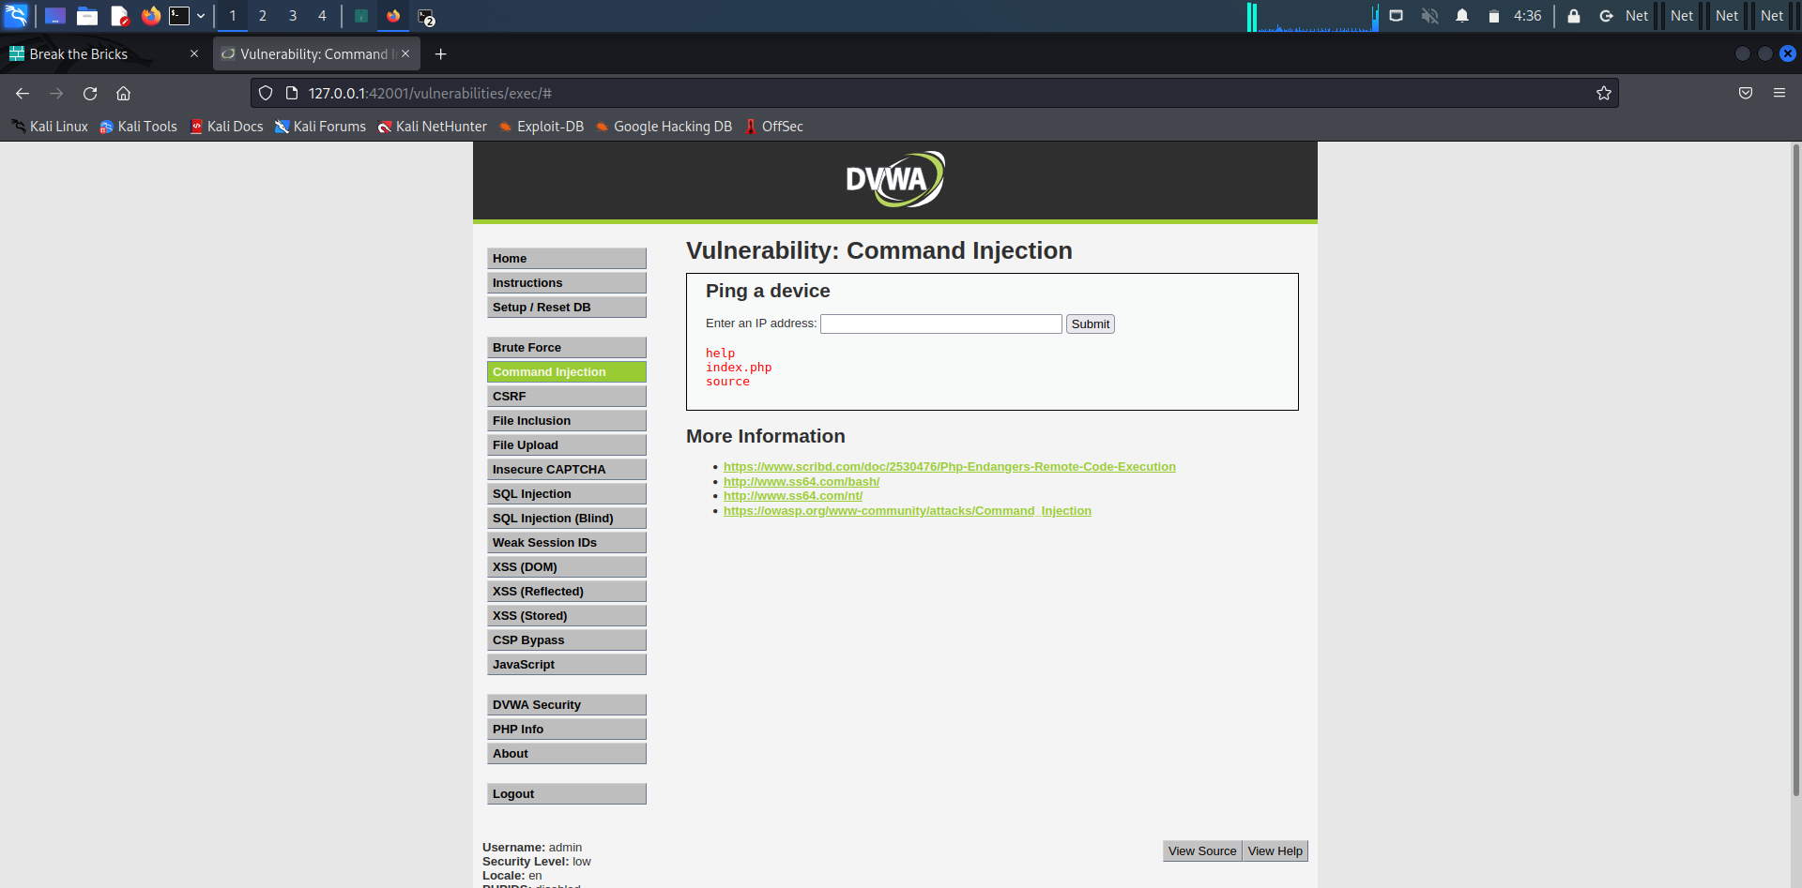

**Security level: medium**

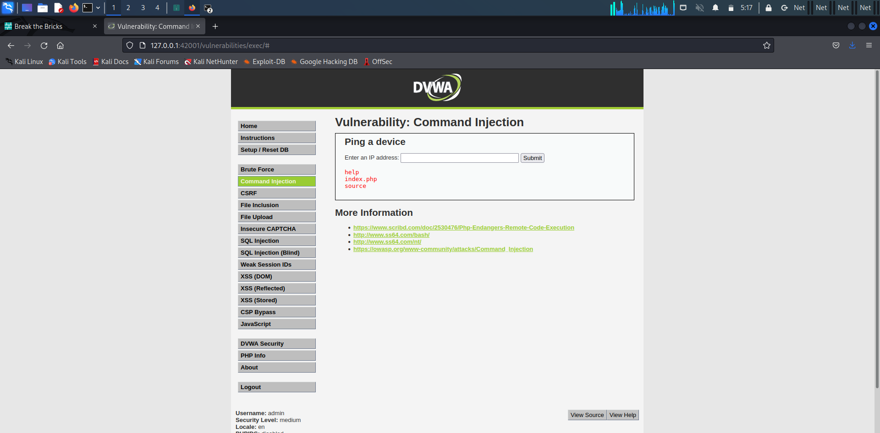

**Security level: high**



**2)File upload vulnerability:**

 file upload vulnerability is a type of security flaw that allows an attacker to upload malicious files onto a server.

**Security level: low**

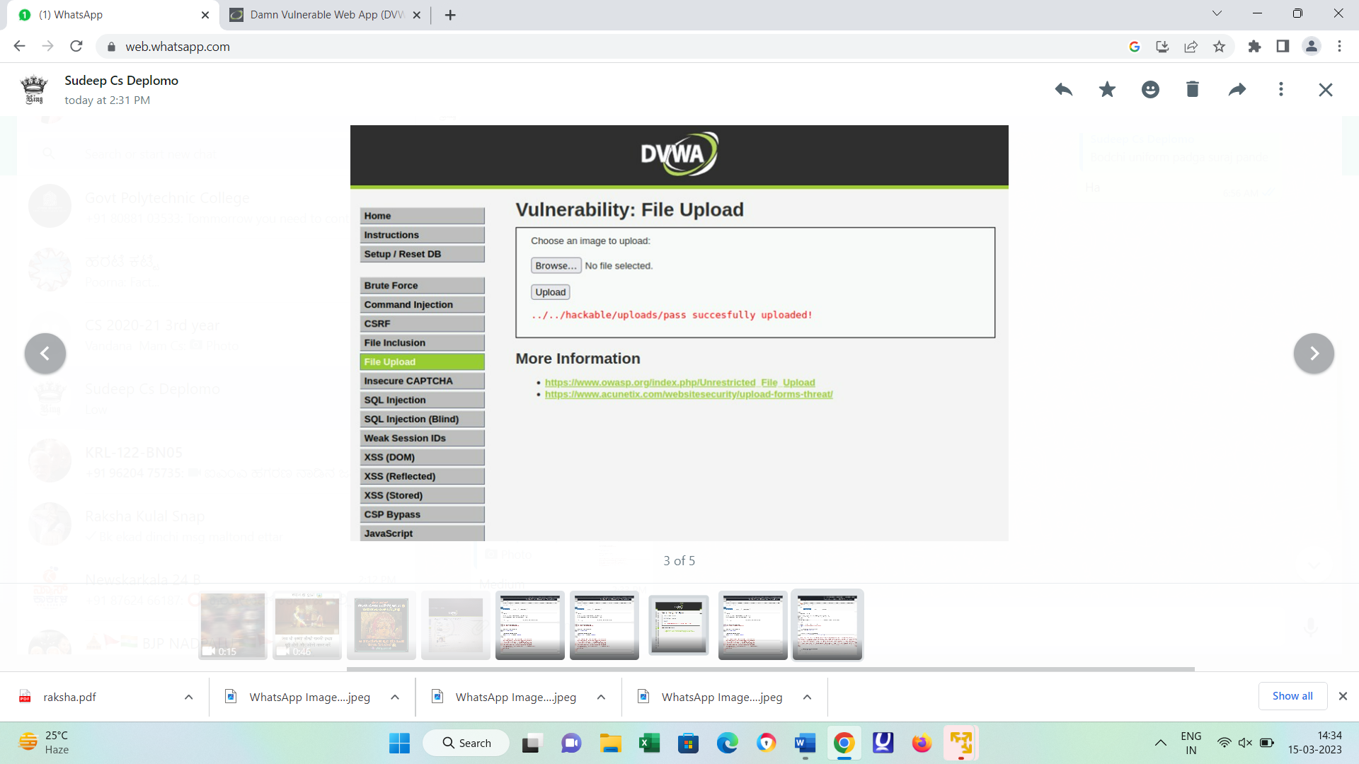

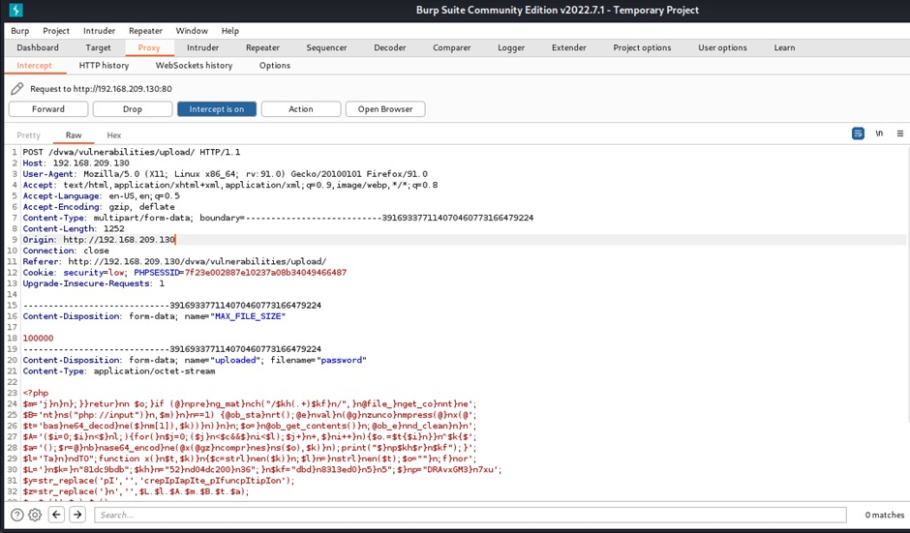

**Security level: medium**



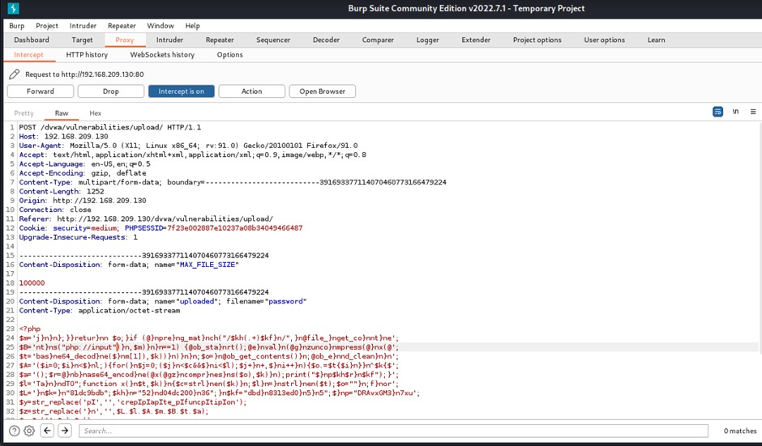

**Security level: high**



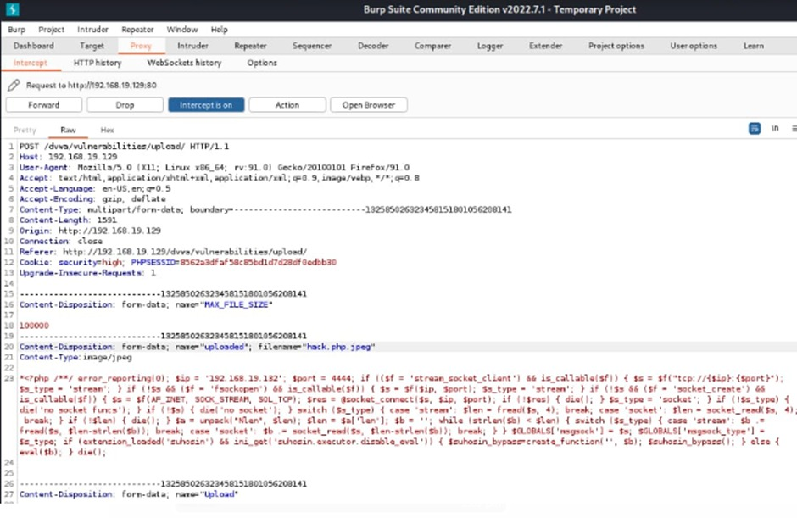

**3)Sql injection vulnerability:**

SQL injection is a code injection technique that might destroy your database. SQL injection is one of the most common web hacking techniques. SQL injection is the placement of malicious code in SQL statements, via web page input.

**Security level: low**

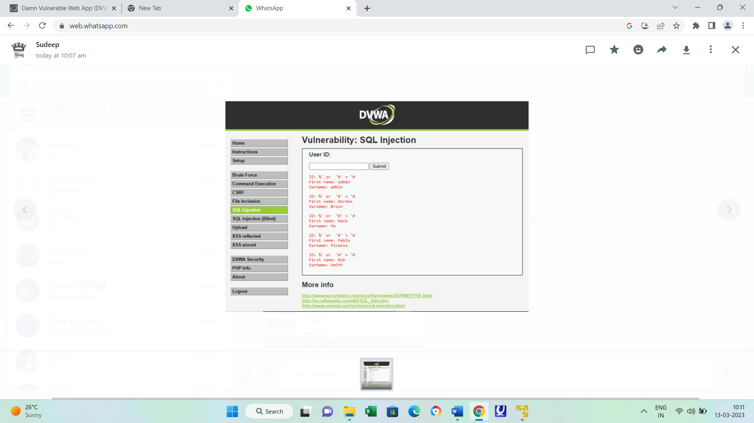

**Security level: medium**



**Security level: high**



**4)Cross site scripting:**

Cross site scripting (XSS) is an attack in which an attacker injects malicious executable scripts into the code of a trusted application or website. Attackers often initiate an XSS attack by sending a malicious link to a user and enticing the user to click it.

**Security level: low**

XSS reflected:

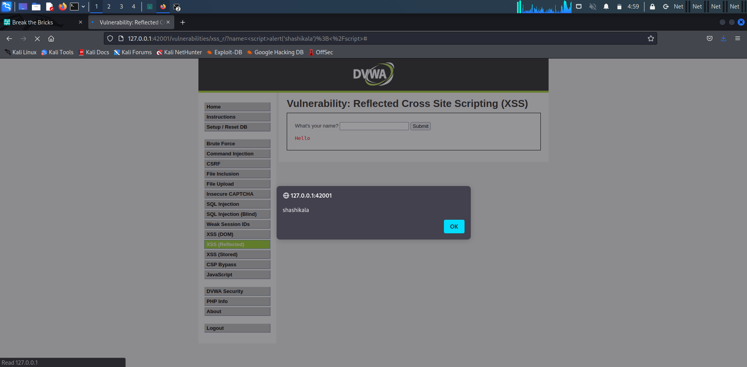

XSS STORED:

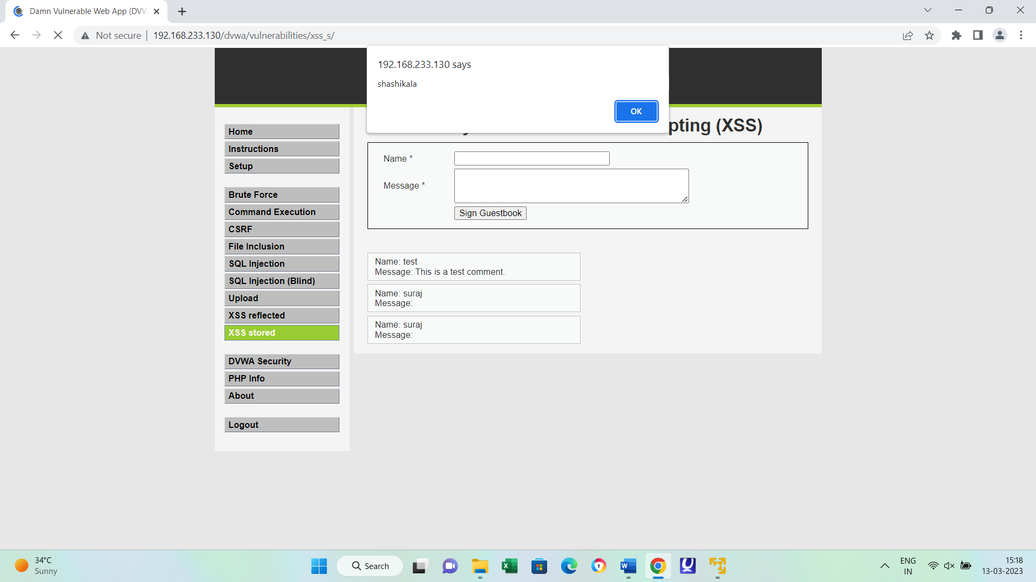

**Security level: medium**

XSS reflected:



XSS stored:



**Security level: high**

XSS reflected:



XSS stored:



**5)Sensitive information disclosure:**

Information disclosure is when a web application fails to properly protect confidential information, which causes revealing sensitive information or data of the users or anything related to users to any third party.

**Security level: low**

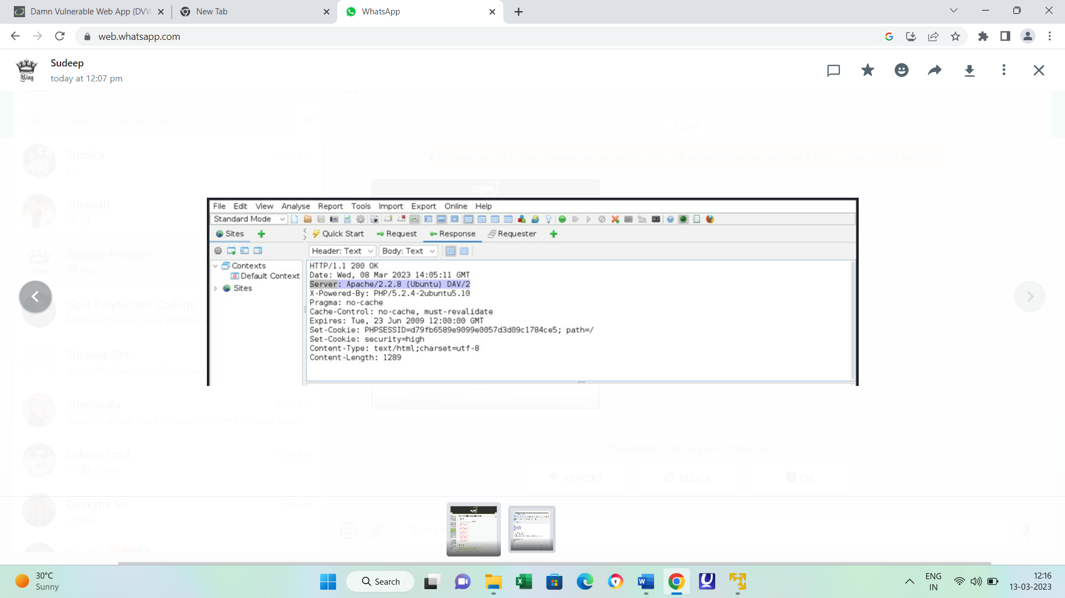

**Security level: medium**



**Security level: high**



**6) Local file inclusion**

Local file inclusion (also known as LFI) is the process of including files, that are already locally present on the server, through the exploiting of vulnerable inclusion procedures implemented in the application.

**Security level: low**

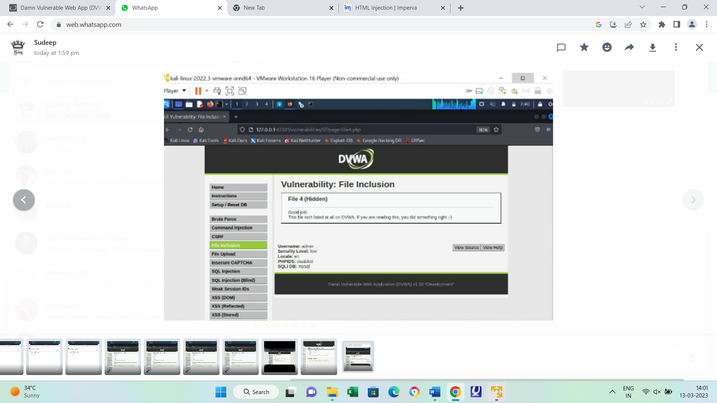

**Security level: medium**

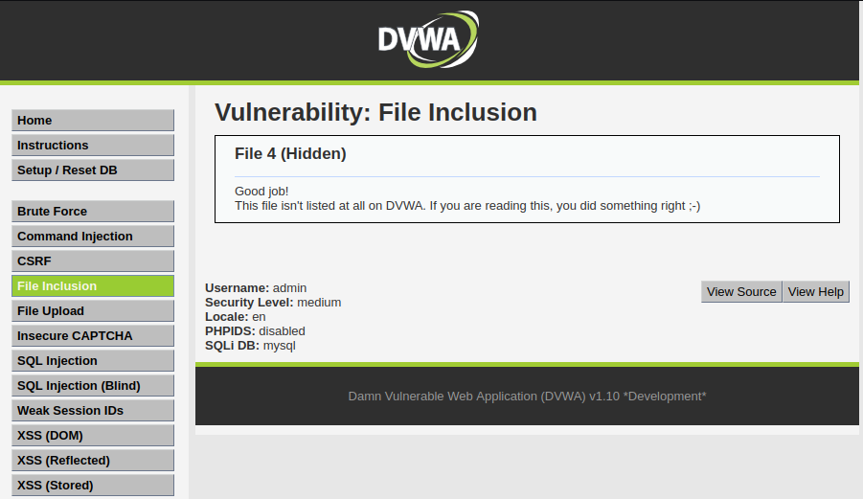

**Security level: high**

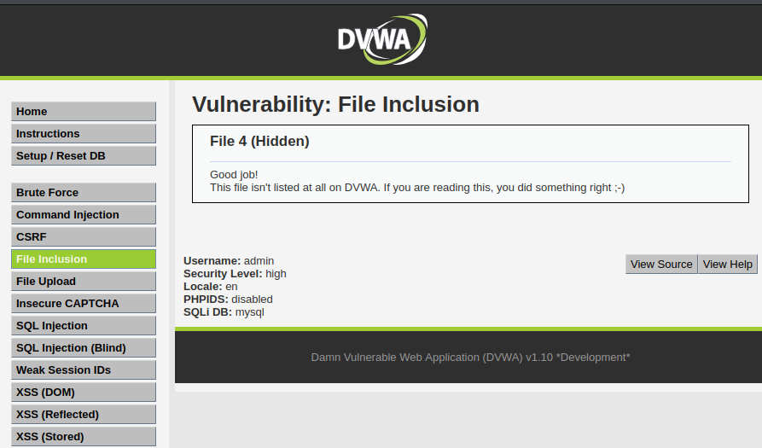

**7)Remote file inclusion:**

Remote file inclusion (RFI) is an attack targeting vulnerabilities in web applications that dynamically reference external scripts. The perpetrator's goal is to exploit the referencing function in an application to upload malware (e.g., backdoor shells) from a remote URL located within a different domain.



**8)Bruteforce attack:**

A brute force attack is uses a trial-and-error approach to systematically guess login info, credentials, and encryption keys. The attacker submits combinations of usernames and passwords until they finally guess correctly.

Security level : low

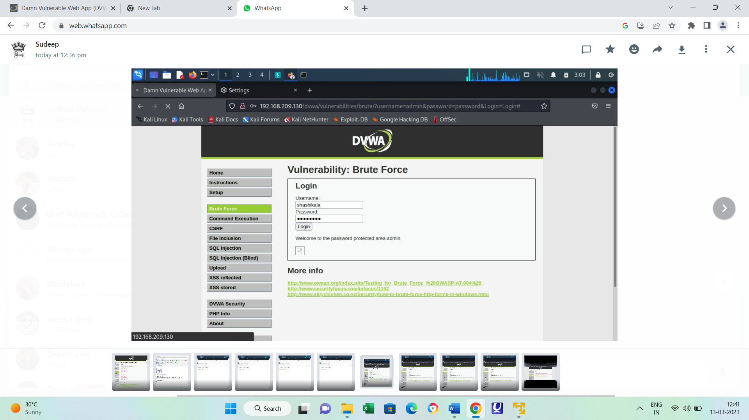

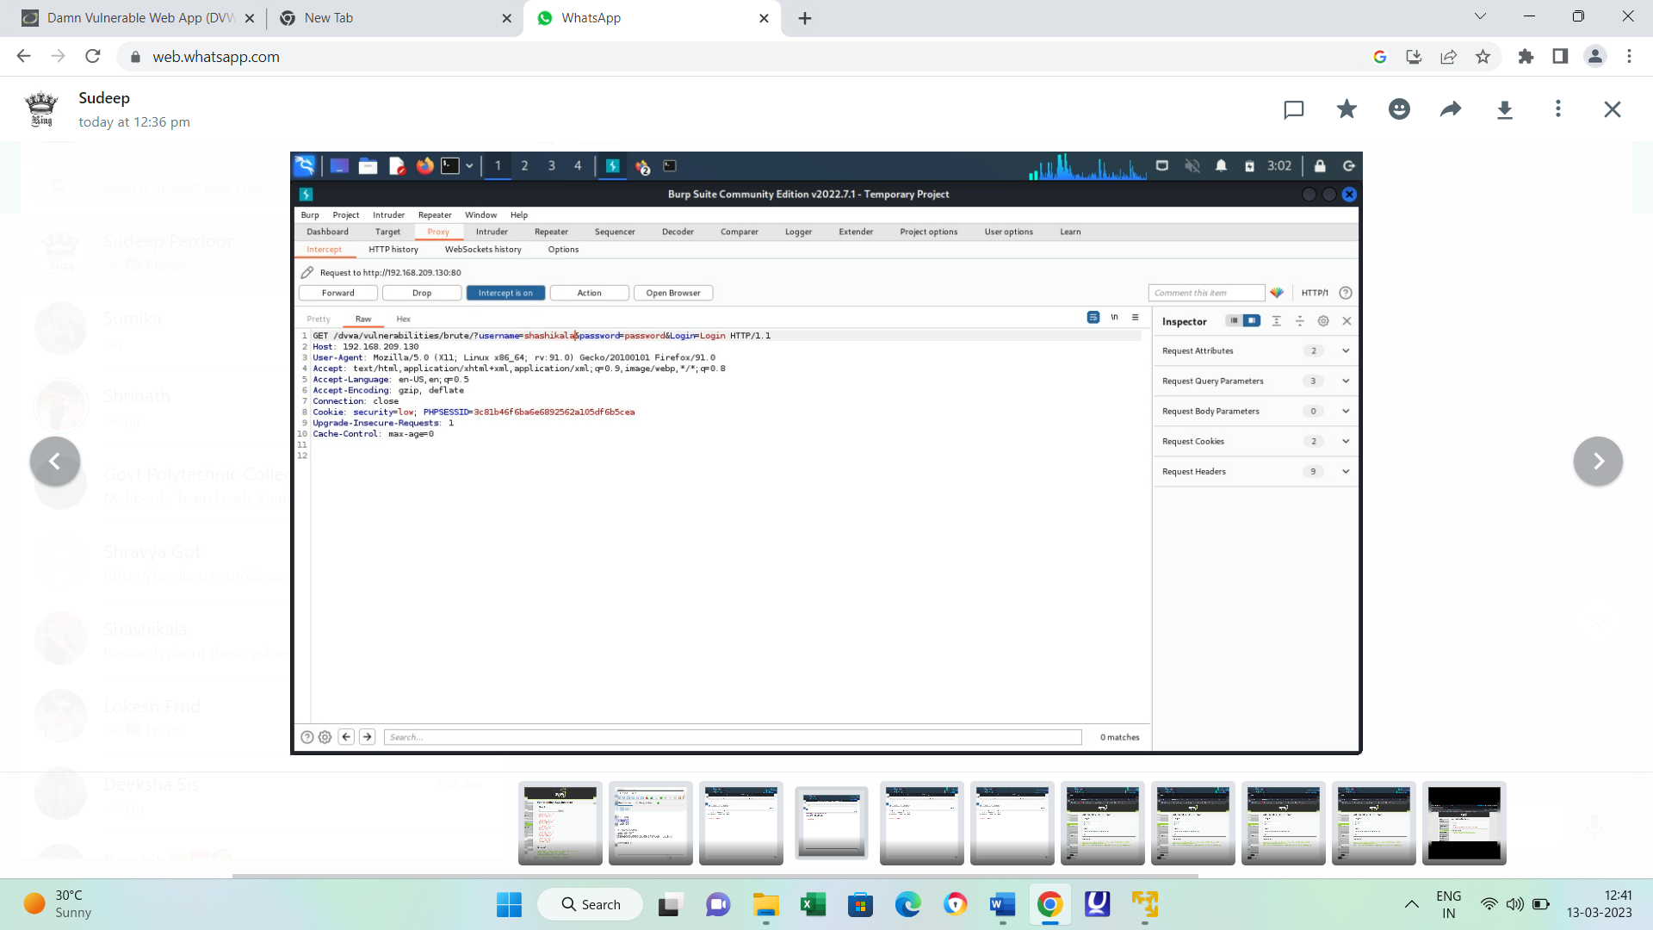

Security level : medium



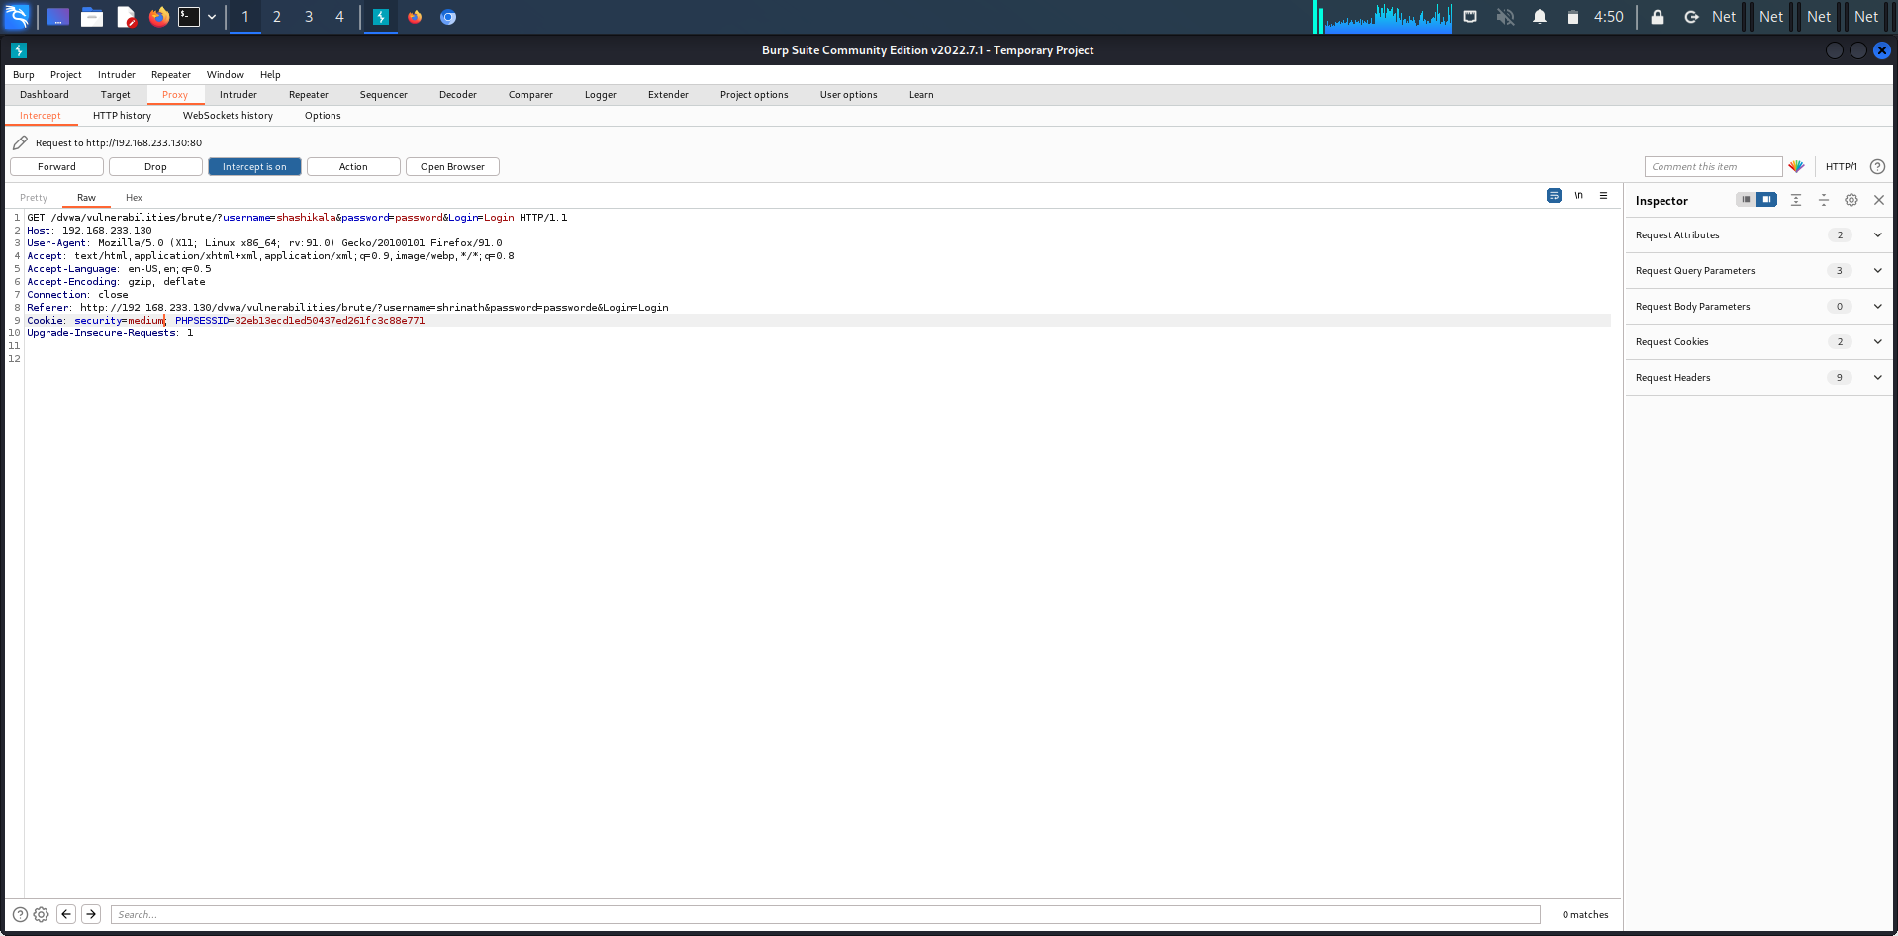

Security level : high



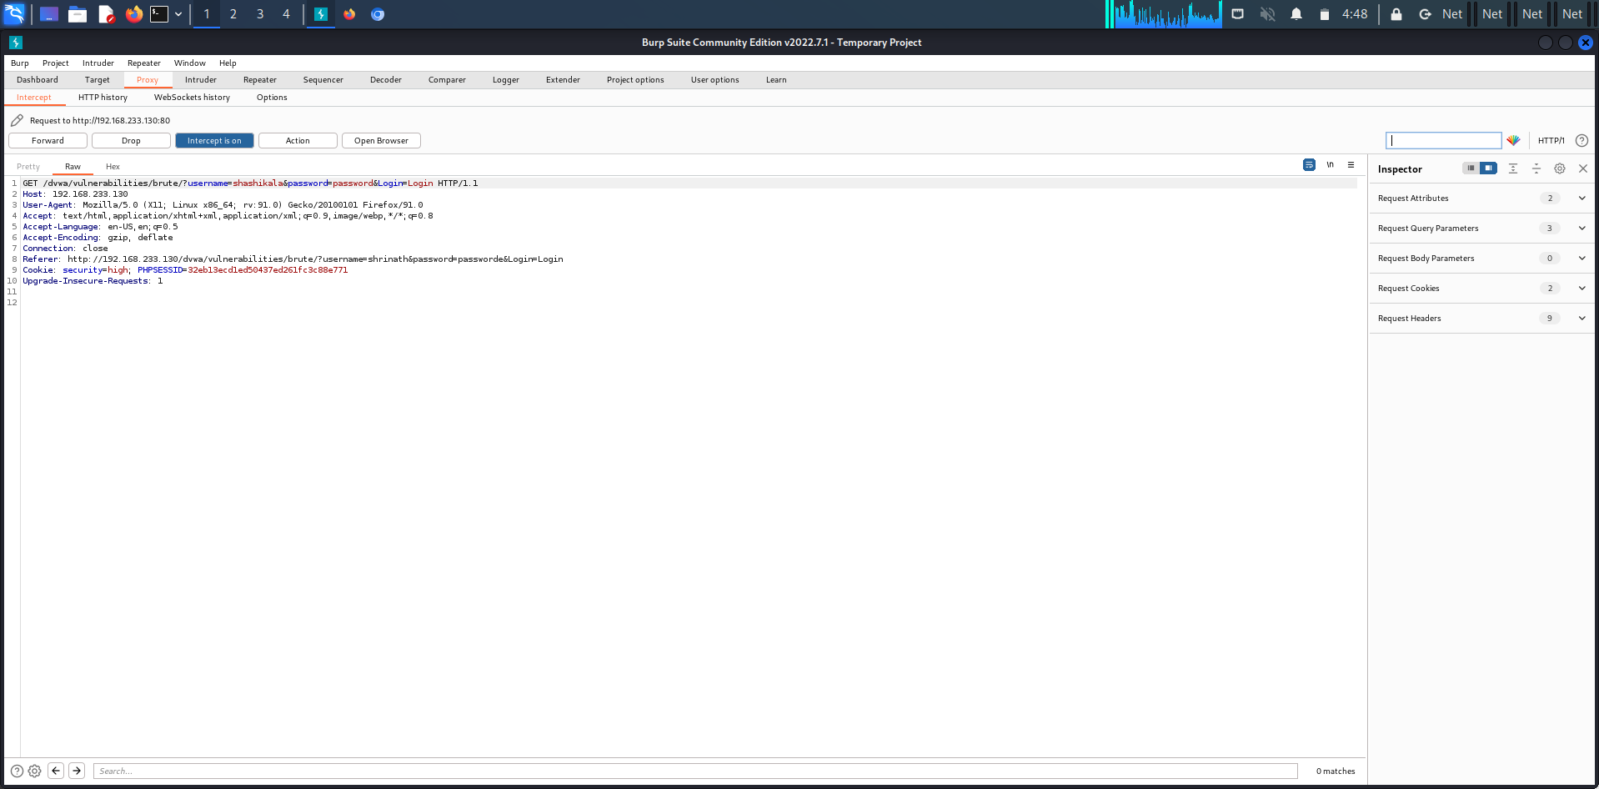

**9)Forced browsing vulnerability:**

Forced browsing attacks are the result of a type of security misconfiguration vulnerability. These kinds of vulnerabilities occur when insecure configuration or misconfiguration leave web application components open to attack. Misconfiguration vulnerabilities may exist in subsystems or software components.

**10)Components with known vulnerability:**

This kind of threat occurs when the components such as libraries and frameworks used within the app almost always execute with full privileges. If a vulnerable component is exploited, it makes the hacker's job easier to cause a serious data loss or server takeover.

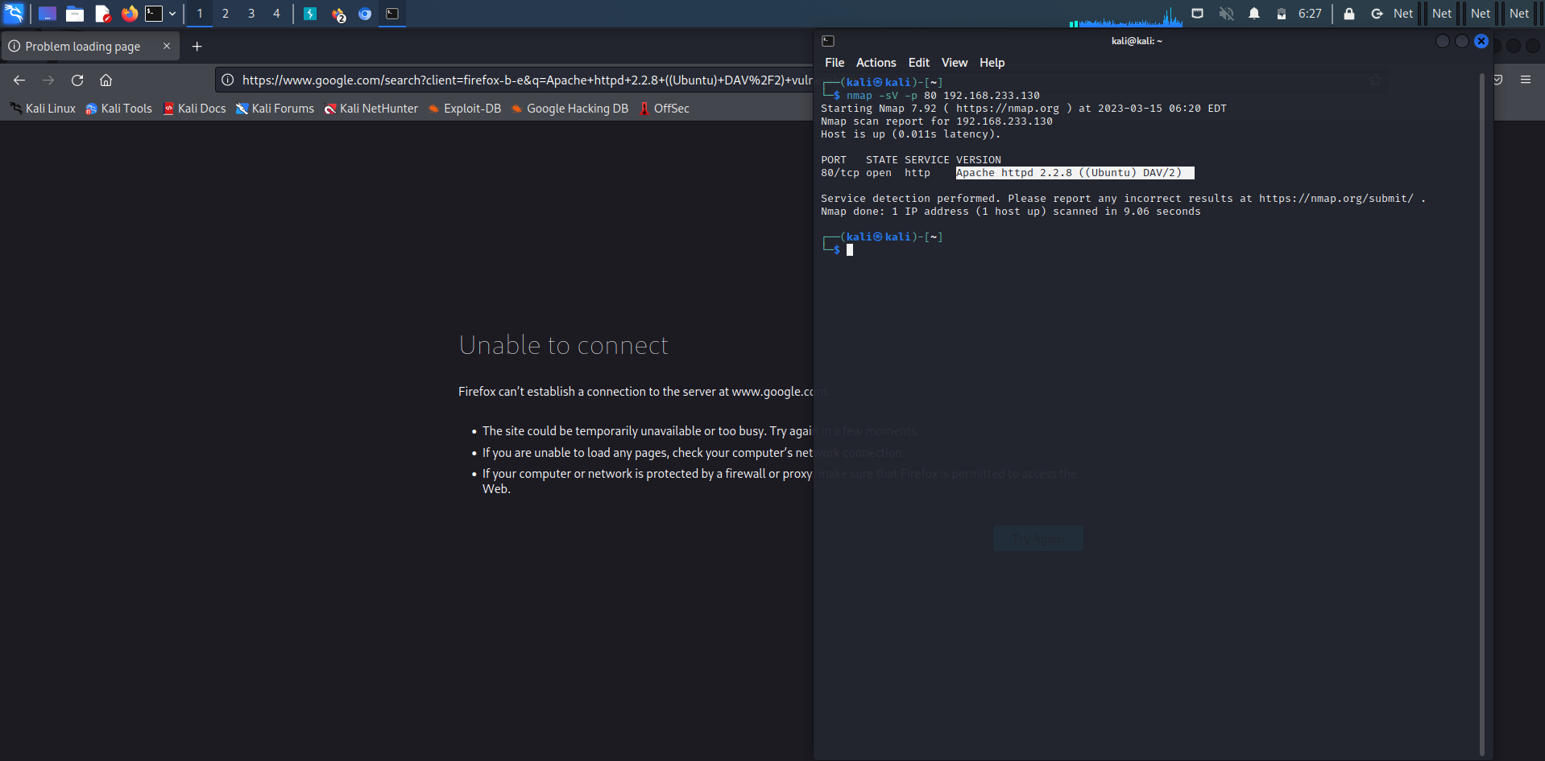

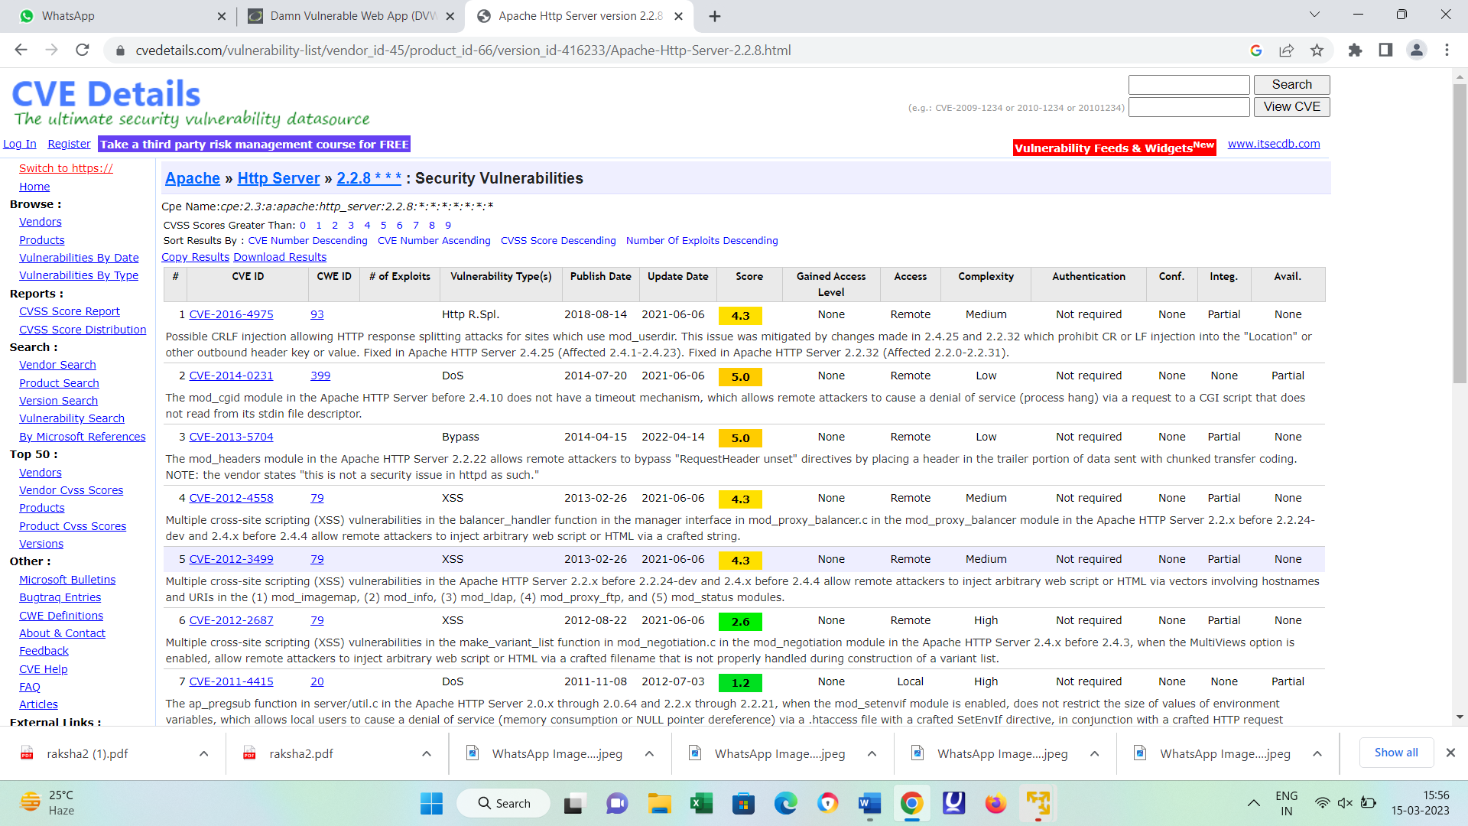

**11)Html injection**

HTML Injection also known as Cross Site Scripting. It is a security vulnerability that allows an attacker to inject HTML code into web pages that are viewed by other users.

**Security level low:**

XSS reflected:



XSS STORED:



**Security level: medium**

XSS reflected:



XSS stored:



**Security level: high**

XSS reflected:



XSS stored:

